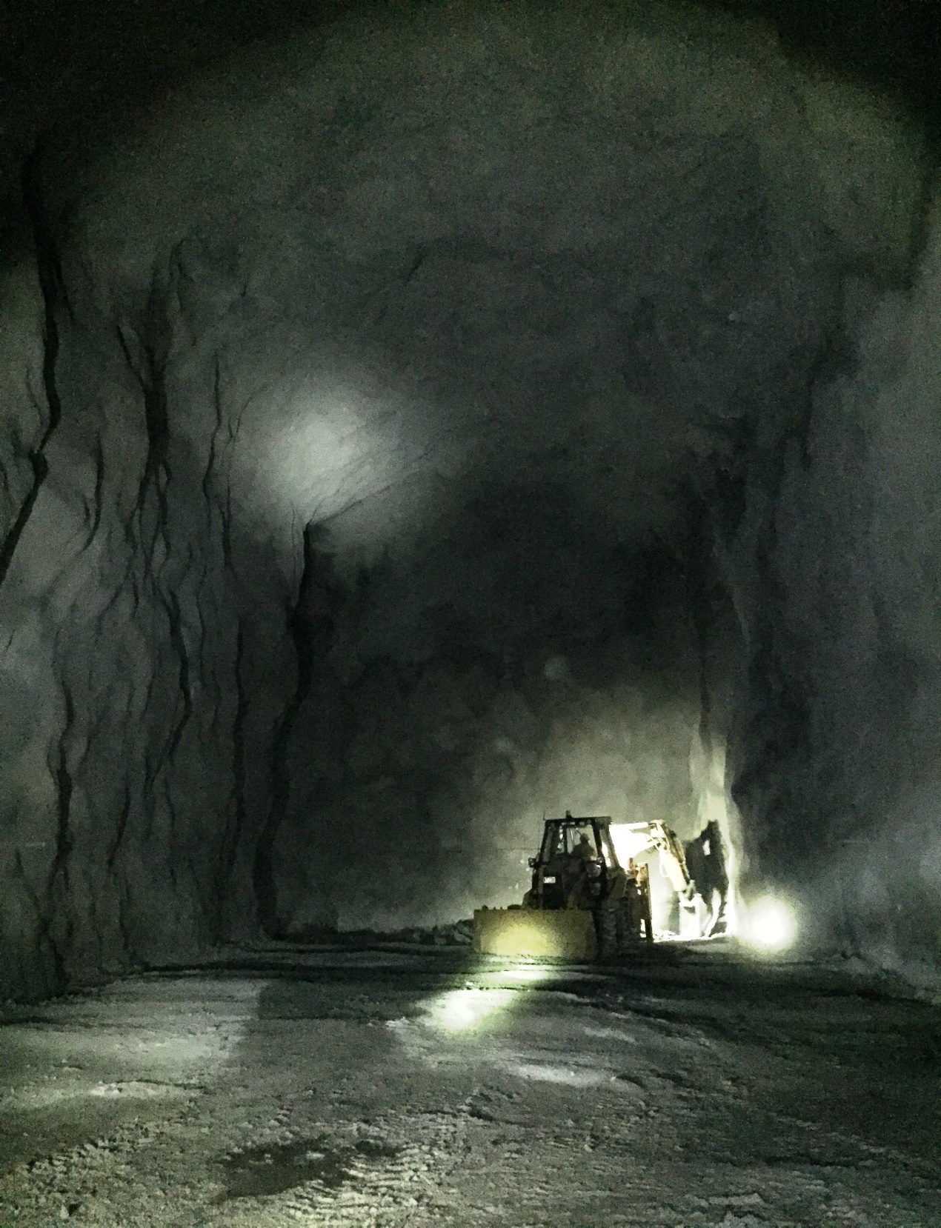
Main experimental hall of SUPL excavated and shotcreted July 2020

